🏥 Hospital Operation & Performance Dashboard (Power BI)

1.Project Overview
The Hospital Operaion & Performance Dashboard is an interactive analytics solution built using Microsoft Power BI to monitor and analyze hospital operations.
It provides insights into:
- Patient activity
- Doctor performance
- Financial metrics
- Medicine inventory
- Hospital resource utilization
The dashboard uses bookmarks, slicers, and dynamic visuals to enable seamless navigation across multiple views.

2. Key Objectives
- Track hospital KPIs in real time
- Improve decision-making using data insights
- Monitor patient flow and discharge trends
- Analyze revenue, costs, and doctor commissions
- Optimize medicine stock and hospital resources

3. 📊 Dashboard Pages & Insights

🔹 Overview Dashboard
- Highest medicine purchases: June (Wednesday = 517 units)
- Highest patient discharge: Oct 2023 (3 patients)
- Total discharged patients: 22
- Discharge rate: 73.33%
- Surgery charges: 0.43M

🔹 Patient Dashboard
- Highest medicine purchases: September (Thursday = 30)
- Top medicine: Atorvastatin (39 units)
- Highest surgery charges: 55K
- Admission Date: 01-Sep-2023
- Discharge Date: 10-Sep-2023
- Medicine Quantity: 131
- Paid Amount: 74K

🔹 Doctor Dashboard
- Patient Fees: 1.65K
- Patient Spend: 84.02K
- Commission Rate: 10%
- Commission Earned: 8.40K
- Estimated Commission: 21.21K

🔹 Hospital Dashboard
- Highest patient age group: 31–45
- Bed availability:
  - General Ward: 55.55% available / 44.44% occupied
  - ICU: 100% available
  - Private: 100% occupied

🔹 Finance Dashboard
- Highest monthly medicine sales: June (839 units)
- Paracetamol stock: 66.05% | Sales: 33.59%
- Surgery revenue: 0.43M
- Healthcare supplies stock: 52.49% | Sales: 47.51%

📈 Key Metrics:
- Total Patients: 30
- Doctors: 15
- Staff: 20
- Bills: 30
- Total Revenue: 714K
- Medicine Sales Qty: 4K
- Total Doctor Salary: 4M
- Avg Doctor Salary: 137.83K
- Avg Patient Age: 45.57
- Commission: 100K
- Doctor Commission: 71.38K
- Avg Unit Price: 10.53
- Avg Spend: 7.60
- Staff Salary: 794K
- Avg Staff Salary: 39.70K
- Stock Value: 42K

4. Data Model & Features

🔗 Data Sources
- Patient Info
- Appointments
- Bills
- Medicine Sales
- Medical Stock
- Staff & Department

⚙️ Features Implemented
- ✔️ Data Modeling (Relationships)
- ✔️ DAX Measures & Calculations
- ✔️ Dynamic KPIs
- ✔️ Bookmark Navigation (Patient & Doctor views)
- ✔️ Conditional Icons (Status Indicators)
- ✔️ Custom Date Formatting
- ✔️ Star Rating Visualization

5. Important DAX Measures
Sum of satisfaction_rating star rating =
VAR __MAX_NUMBER_OF_STARS = 5
VAR __MIN_RATED_VALUE = 0
VAR __MAX_RATED_VALUE = 5
VAR __BASE_VALUE = COALESCE(SUM('patient_info'[satisfaction_rating]), 0)

VAR __NORMALIZED_BASE_VALUE =
MIN(
MAX(
DIVIDE(
__BASE_VALUE - __MIN_RATED_VALUE,
__MAX_RATED_VALUE - __MIN_RATED_VALUE,
0
),
0
),
1
)

VAR __STAR_RATING =
ROUND(__NORMALIZED_BASE_VALUE * __MAX_NUMBER_OF_STARS, 0)

RETURN
REPT(UNICHAR(9733), __STAR_RATING)
& REPT(UNICHAR(9734), __MAX_NUMBER_OF_STARS - __STAR_RATING)

Appointment_ Time_Date = FORMAT(appointments[appointment_time],"hh:mm AM/PM") &"-"& FORMAT(appointments[appointment_date],"dd-mmm")

Ap_Status_Icon =
VAR statusValue = SELECTEDVALUE(appointment[status])
RETURN
IF(
statusValue = "completed",
[Check_Icon],
[Calender_Icon]
)

Doctor_Fees = CALCULATE(SUM(bills[Value]),bills[Charge_Type]="Fees")

Total_Bill_Amt =
VAR Discount =
CALCULATE(
SUM(bills[Value]),
bills[Charge_Type] = "Discount"
)
VAR TotalAmount =
SUM(bills[Value])
RETURN
TotalAmount – Discount

Total_Bill_Amt =
VAR Discount =
CALCULATE(
SUM(bills[Value]),
bills[Charge_Type] = "Discount"
)
VAR TotalAmount =
SUM(bills[Value])
RETURN
TotalAmount - Discount
Total_Med_Sales_Qty = SUM(medicine_patient[qty])

DR_Commission_Rate = 0.10

DR_Commission_Amt = [Total_Bill_Amt]*[DR_Commission_Rate]

Esitmated_ Commision = VAR Patient_Amt=MAX('Esitmated_ Patient_Amt'[Esitmated_ Patient_Amt])VAR Commision_Rate =MAX('Esitmated_ Commision _Rate'[Esitmated_ Commision _Rate])VAR Commision_Per=DIVIDE(Commision_Rate,100) RETURN Patient_Amt*Commision_Per

Surgery_Appointment_ Time_Date = FORMAT(patient_info[surgery_appointment_time],"hh:mm AM/PM") &"-"& FORMAT(patient_info[surgery_appointment_date],"dd-mmm")

Surgery_Status_Icon =
VAR statusValue = SELECTEDVALUE(patient_info[surgery_status])
RETURN
IF(
statusValue = "completed",
[Check_Icon],
[Calender_Icon]
)
Check_Icon = "https://i.ibb.co/wZg6WTDB/check-mark.png"
Calender_Icon = "https://i.ibb.co/V0vkPwT2/calendar-1.png"

Age_Category = VAR Age=patient_info[patient_age] RETURN SWITCH(TRUE(),Age>=18&&Age<=30,"18 To 30",Age>=31&&Age<=45,"31 To 45",Age>=46&&Age<=60,"46 To 60",Age>60,"60+",Age<18,"Under18",BLANK())

Patient_Count=DISTINCTCOUNT(patient_info[patient_id])

Average_Med_Sales_Qty = AVERAGE(medicine_patient[qty])

Total_Stock_Qty = SUM(medical_stock_info[stock_qty])

Stock Value =
SUM(medical_stock_info[stock_qty]) * AVERAGE(medical_stock_info[unit_price])

Format_Discharge_Date = FORMAT(patient_info[patient_discharge_date],"mmm-yy")

Discharge_Index = MONTH(patient_info[patient_discharge_date])

Admitted_status = "Total" & CALCULATE(patient_info[Patient_Count],patient_info[patient_status] ="Admitted")&"Patient Admitted."

Discharge_Patient = CALCULATE(patient_info[Patient_Count],patient_info[patient_status]="Discharged")
Discharge% = VAR All_Patient=CALCULATE(patient_info[Patient_Count],ALL(patient_info[patient_status])) RETURN DIVIDE([Discharge_Patient],All_Patient)

6. UI/UX Highlights
- Clean hospital-themed layout
- Icon-based indicators for status
- Interactive filters and slicers
- Bookmark-based navigation
- Responsive and user-friendly design

7. 💡 Business Recommendations

🏥 Operations
- Increase capacity in Private wards (100% occupied)
- Optimize underutilized ICU resources

💊 Inventory
- Maintain buffer stock for high-demand medicines like Atorvastatin
- Improve stock planning using monthly trends

💰 Finance
- Focus on high-revenue services like surgery
- Optimize discount strategy to improve net revenue

👨‍⚕️ Doctors
- Review commission structure to align incentives
- Monitor doctor-wise performance and patient handling

👥 Patients
- Reduce discharge delays to improve bed turnover
- Enhance patient satisfaction tracking using rating system
8. 📷 Screenshots

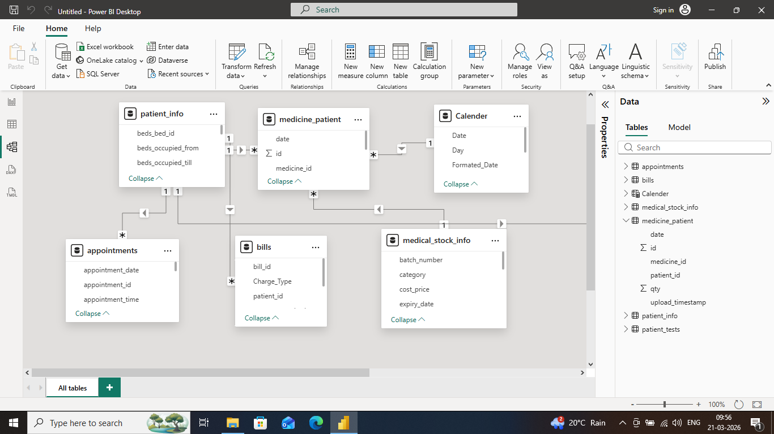
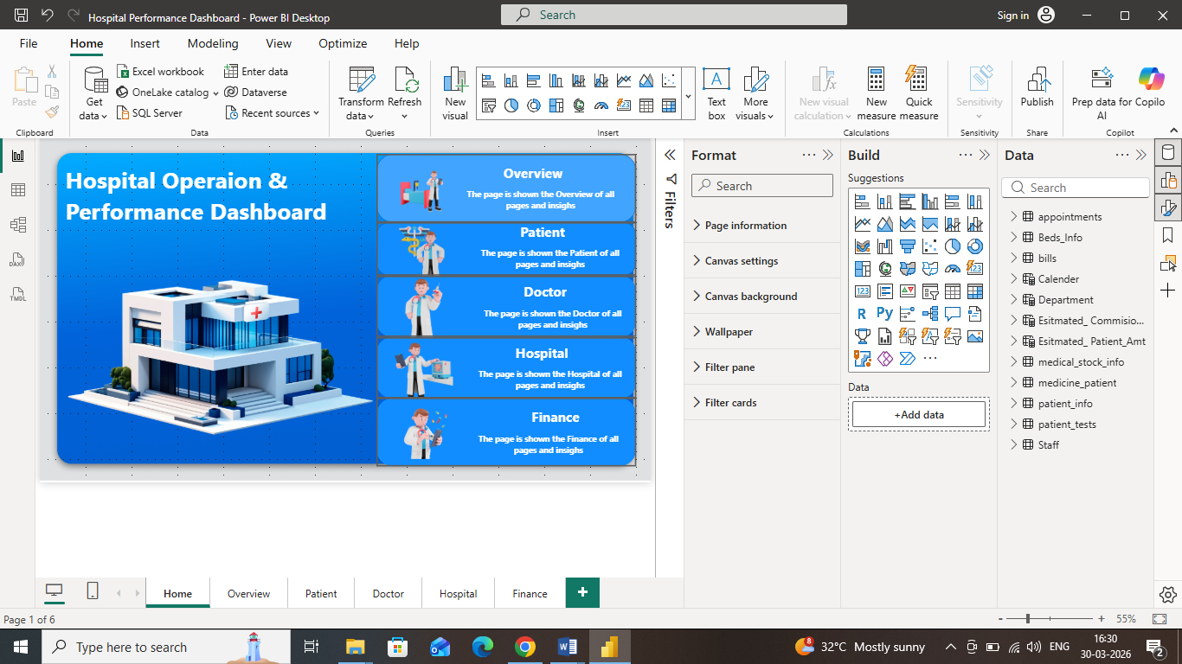
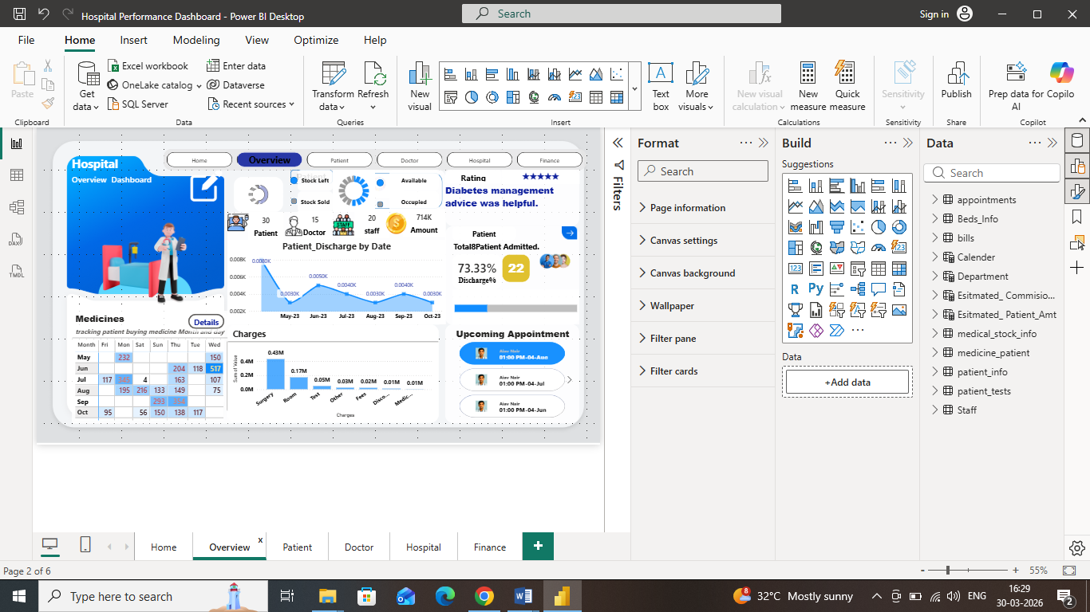
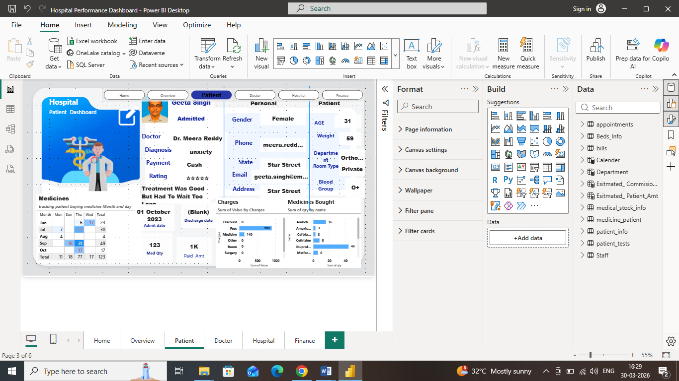
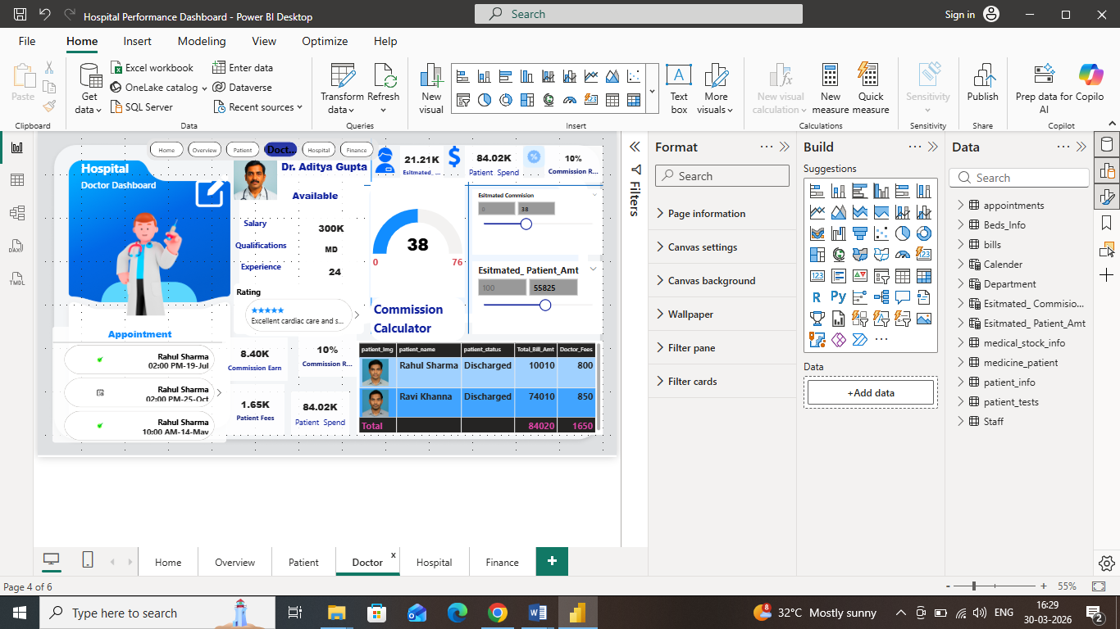
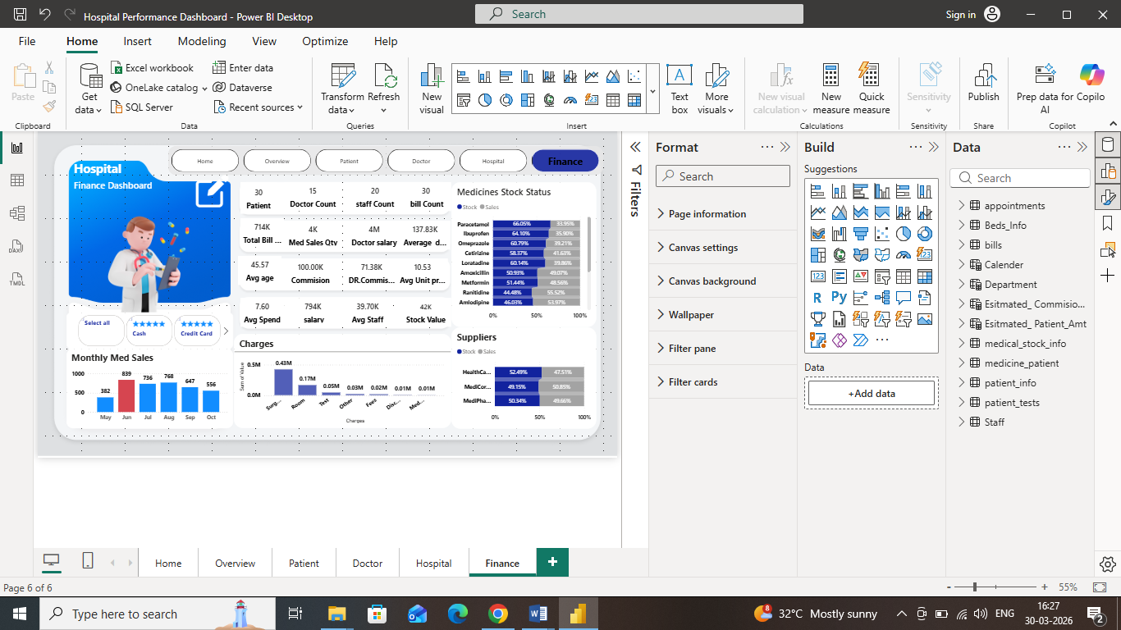

9. Conclusion
This dashboard provides a 360° view of hospital performance, helping stakeholders make data-driven decisions in operations, finance, and patient care.

Deepak Kumar Tekchandani
Power BI|DAX (Data Analysis Expressions)|Data Modeling|Data Cleaning & Transformation|Interactive Data Visualization
📧 deepakkumartekchandani@gmail.com
🔗 LinkedIn: www.linkedin.com/in/deepak-kumar-tekchandani-b7200a146
💻 GitHub: https://github.com/DTekchandani1/Hospital-Operation-Performance-Dashboard.git

